Alencon Systems – Passionate About Power
Copyright © 2020 Alencon LLC, Inc. | All rights reserved.
SPOT – String Power Optimizer and Transmitter
A unique PV harvesting system of DCDC Optimizers for generating more energy in Repowering, Solar + Storage and Microgrid Applications
Installation, Operation and Maintenance Manual for use with the SPOT-V6-600/1000 or SPOT-V6-1500
This Document is the confidential and proprietary information of Alencon Systems LLC. No part of this document may be reproduced, stored in a retrieval system, or transmitted, in any form or by any means, electronic, mechanical, photographic, magnetic or otherwise, without prior written permission.
Copyright Information: Any product names listed in this manual that are not registered trademarks of Alencon Systems LLC and/or organization names mentioned may be trademarks and/or registered trademarks of their respective companies.
Publication Number: PM001 Revision 11
REVISION LOG:
Rev # | ECO | Date | Author | Approval | Comment
00 | 8562 | 12/10/17 | H. Fishman | OF | Original Release
01 | 8563 | 12/10/18 | P. Shivshankaran | HF | Modification to incorporate new features on SPOT V6
02 | 8564 | 1/22/19 | P. Shivshankaran | HF | Added updated pictures of SPOT with Amphenol connectors, other edits.
03 | 8565 | 1/25/19 | P.Shivshankaran | HF | Removed all comments.
04 | 8566 | 3/04/19 | P.Shivshankaran | HF | Updated Spec sheet and Label information
05 | 8567 | 3/05/19 | P.Shivshankaran | HF | Made changes to SPOT weight. Additional installation steps added
06 | 8568 | 11/18/19 | P.Shivshankaran | HF | Cleaned up updates & redundancies. Addition of mounting procedure and pictures
07 | 8569 | 02/03/2020 | P.Shivshankaran | PS | Removed Modbus Map Information
08 | 8570 | 04/21/2020 | A.Finashin | AF | Changed the SPOT naming for 600/1000 and 1500
09 | 8571 | 12/16/2020 | J. Faber | HF | Updated with FEED info
10 | 8572 | 02/16/2021 | J. Faber | HF | Output disconnect warning
11 | 8573 | 12/30/2021 | J. Faber | HF | Operations updated

Disclaimer
Alencon LLC makes no representations, express or implied, with respect to this documentation or any of the equipment and/or software it may describe, including (with no limitation) any implied warranties of utility, merchantability, or fitness for any particular purpose. All such warranties are expressly disclaimed. Alencon LLC shall not be liable for any incidental, or consequential damages under any circumstances.

Specifications are subject to change without notice. Every attempt has been made to make this document complete, accurate and up to date. Readers are cautioned, however, that Alencon LLC reserves the right to make changes without notice and shall not be responsible for any damages, including indirect, incidental, or consequential damages, caused by reliance on the material presented, including, but not limited to, omissions, typographical errors, arithmetical errors or listing errors in the content material.
Contents
Disclaimer 2
1 Table of Figures 5
2 General Information 6
2.1 Purpose 6
2.2 Product Warranty 6
2.3 Warnings, Cautions and Notes 7
2.4 Packing List 8
2.5 Ordering Information 8
3 Important Safety Instructions 9
4 SPOT Applications 11
4.1 New PV Plants 12
4.2 Solar + Storage 13
4.3 Repowering of Older PV Plants 14
5 Technical Specifications 16
6 Isolators / Disconnects 18
6.1 Alencon Fused Electrical Disconnect (FEED) 18
6.2 Alencon Isolated Disconnect (AID) 19
6.3 Third Party Disconnects 19
6.4 Alencon GARDTM 20
7 SPOT Hardware 21
7.1 SPOT Dimensions – Vertical Mount 22
7.1 SPOT with FEED Dimensions – Horizontal Mount 23
8 Installation 24
8.1 Installation Criteria – PV 24
8.1.1 Voltage and Current Requirements 24
8.2 Installation Procedure 25
8.3 Locate the System Layout Schematic and/or Installation Drawing 25
8.4 SPOT Mounting 28
8.4.1 Selecting Location – Vertical Rail Mount 28
8.4.2 Selecting Location – Horizontal Rack Mount 29
8.4.3 Mounting Procedure – Vertical Rail Mount 30
8.4.4 Mounting Procedure – Horizontal Rack Mount 31
8.5 SPOT Grounding Requirements 33
8.6 Connecting the SPOT to Input Power Source Cables 34
8.6.1 SPOT Wiring Requirements 34
8.6.2 Input Wiring 34
8.6.3 SPOT Connector Terminations 34
8.6.4 Short Circuit Check 35
8.7 Connecting the SPOT to Output/Load Cables 35
8.7.1 Output Wiring 35
9 Turning ON and OFF the SPOT 36
9.1 Steps to turn ON the SPOT: 36
9.1.1 Turning ON the SPOT – Low Voltage Bus (<300V) 36
9.1.2 Turning ON the SPOT – High Voltage Bus (>300V) 36
9.2 Steps to turn OFF the SPOT: 37
9.3 Commissioning your SPOT Device 37
10 SPOT Operation 38
10.1 STATE Machine 38
10.1.2 COMMANDS 41
10.1.3 CONDITIONS 41
11 Maintenance and Servicing 43
11.1 General Maintenance 43
11.2 Service and Repair 43
12 Alencon Communication Environment (ACE) 44
12.1 System Overview 44
Appendix A - Safety Precautions 45
A.1 Degree of Danger Symbols 45
A.2 Electrical hazards 45
A.2.1 Electric shock from live voltage 45
A.2.2 Danger due to Battery Voltage 46
A.2.3 Electric shock caused by ground fault 46
A.2.4 Electric shock due to damaged equipment 46
A.3 Environmental hazards 46
A.3.1 Danger to life due to blocked escape routes 46
A.3.2 Damage to the equipment caused by dust or moisture penetration 46
A.3.3 Danger to life due to electric shock when the equipment is unlocked 47
Appendix B – Glossary 47
Appendix C – Technical Support and Assistance 48

1 Table of Figures
Figure 1: A picture of a SPOT unit 8
Figure 2: The graphic above indicates that the SPOT is a grounding conductor. 9
Figure 3: The graphic above indicates that the SPOT acts as a direct current supply. 9
Figure 4: SPOT units placed between PV panel and combiner. 11
Figure 5: Diagram of deployed SPOT units in a newly constructed PV plant 12
Figure 6: Diagram of a DC-coupled Solar + Storage system using the SPOT 13
Figure 7: Negatively grounded PV array connected to neutrally grounded Inverter 14
Figure 8: A typical 600V PV plant with Alencon spots and a transformer-less inverter 15
Figure 9: Alencon SPOT with Fused Electrical Disconnect 18
Figure 10: Alencon Isolated Disconnect (external and Internal) 19
Figure 11: An IMO manual DC isolator 19
Figure 12: SPOTs with IMO disconnect 20
Figure 13: GARD 20
Figure 14: Solar Power Optimizer and Transmitter (SPOT) – Vertical Mount 21
Figure 15: SPOT with Fused Electrical Disconnect (FEED) – Horizontal Mount 21
Figure 16: SPOT Dimensions including back plane for hanging 22
Figure 17: SPOT with FEED Dimensions 23
Figure 18: Sample of a Single Line Diagram (SLD) 26
Figure 19: SPOT Bottom End Plate with commensurate labels 27
Figure 20: Sample SPOT Label 27
Figure 21: SPOT Mounting Instructions 31
Figure 22: SPOT/BOSS with FEED and Mounting Brackets 32
Figure 23: SPOT/BOSS with FEED and Mounting Brackets 32
Figure 24: SPOT Ground Lug Location Examples (in Orange) 33
Figure 25: State Space Flow Chart 39
Figure 26: PODD - Points of Data Distribution device 44

2 General Information
All efforts have been made to ensure the accuracy of material provided in this document at the time of release. Items are subject to continuous development and improvements. All specifications and descriptions are subject to change without notice.

2.1 Purpose
This manual provides information about installing, operating, maintaining, and troubleshooting the Alencon SPOT device.
Who Should Read this Manual?
This manual should be read by anyone who needs to:
- Understand the product
- Plan the installation
- Install the product
- Commission the product
- Operate the product
- Maintain the product, if necessary

2.2 Product Warranty
Alencon Systems warrants to you, the original purchaser, that each of its products will be free from defects in materials and workmanship for three years from the date of purchase. Extended warrantees of an additional five (5), ten (10) and twenty (20) years are also available for purchase.

This warranty does not apply to any products which have been repaired or altered by persons other than repair personnel authorized by Alencon System, or which have been subject to misuse, abuse, accident, or improper installation. This warranty does not cover the repair or replacement of any goods which fail as a result of damage in transit, misuse, neglect, accident, Act of God, abuse, improper handling, misapplication, modification, improper storage, excessive stress, faulty or improper installation, testing or repair, negligent maintenance, or failure to comply with the written instructions for installation, testing, use or maintenance (if any) provided by Alencon Systems. Alencon Systems assumes no liability under the terms of this warranty as a consequence of such events.

Because of Alencon Systems’ high quality-control standards and rigorous testing, most of our customers never need to use our warranty service. If an Alencon Systems product is defective, it will be repaired or replaced at no charge during the warranty period. For out-of-warranty repairs, you will be billed according to the cost of replacement materials, service time and freight. Please consult Alencon Systems for more details. If you think you have a defective product, follow these steps:
- Collect all the information about the problem encountered. (For example, issues you are encountering in your PV array) Note anything abnormal when the problem occurs.
- Call Alencon Systems or your licensed Alencon Systems dealer and describe the problem. Please have your manual, product, and any helpful information readily available.
- If your product is diagnosed as defective, obtain an RMA (return merchandise authorization) number from Alencon Systems. This allows us to process your return more quickly.
- Carefully pack the defective product (preferably in the original packaging material it was shipped in), a fully completed Repair and Replacement Order Card and a photocopy proof of purchase date (such as your sales receipt) in a shippable container. A product returned without proof of the purchase date is not eligible for warranty service.

2.3 Warnings, Cautions and Notes
 | Warning! | Warnings indicate conditions, which if not observed, can cause personal injury!
 | Caution! | Cautions are included to help you avoid damaging hardware or losing data.
 | Note! | Notes provide optional additional information.

2.4 Packing List
The SPOT is assembled and fully tested at the ALENCON factory. Before installation, please ensure the following items have been shipped:
- Commensurate # of SPOT units specified for your project.
- 4 AWG Single Wire Grounding Mechanical Lug per SPOT unit
- 1 x Warranty Card
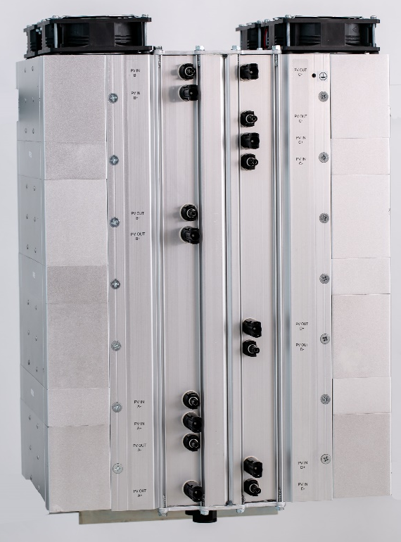
Figure 1: A picture of a SPOT unit

2.5 Ordering Information
Model Number Description
Model Number | Description
SPOT-X4-V6-600/1000 | Alencon Systems String Power Optimizer & Transmitter, Four MPPT, 600-1000VDC Input
SPOT-X4-V6-1500 | Alencon Systems String Power Optimizer & Transmitter, Four MPPT, 1500VDC Input

3 Important Safety Instructions

SAVE THESE INSTRUCTIONS– This manual contains important instructions for use with the SPOT 600/1000 and 1500 that shall be followed during installation and maintenance of these devices.
Figure 2: The graphic above indicates that the SPOT is a grounding conductor.
Figure 3: The graphic above indicates that the SPOT acts as a direct current supply.
Installation of this equipment must be performed by an authorized electrician in accordance with the local and NEC ANSI/NFPA 70 and OSHA requirements.

- Before installing and using the SPOT, read all instructions presented in this manual and the cautionary markings shown on the SPOT's enclosure.

- The SPOT contains no user-serviceable parts. For service and maintenance, the SPOT should be returned to Alencon Systems LLC or a certified Alencon Systems service center.

- During operation, hazardous voltages and currents may be present. Only authorized and qualified personnel should perform servicing/installation.

- Disconnect switches or contactors must be used between SPOT inputs and PV arrays (or other input source).

- Do not disconnect the SPOT output while under LOAD. Always use input disconnect switch to shutdown SPOT before disconnecting the output.

- The SPOT requires external fusing. This requirement is explained in detail in Section 5.13.2 of this manual “Output Wiring.”
- Exposed PV strings to sunlight represent a shock hazard at the PV wires and exposed terminals. Disconnect SPOT input switches or contactors before performing any work on the SPOT. Test any terminal for voltage before touching them. Check if any current is flowing through the strings before disconnection.

- Use only accessories recommended or approved by the manufacturer.

- Ensure that wiring is in good conditions and that all wiring is sized according to NEC 310-16 specifications.

- PV modules produce electrical energy when exposed to light and thus can create an electrical shock hazard. Wiring of the PV modules should only be performed by qualified personnel.

- Always have SPOT manual on hand, for reference.

4 SPOT Applications
The SPOT is a set of 4 galvanically isolated DC-to-DC converters, that operate between a variety of possible DC sources (PV, fuel cell, battery, etc.) and loads (inverter, battery, motor, etc.). Most commonly, a SPOT is placed between PV strings and a combiner box as shown in figure 5.
SPOT can provide:
- Granular MPPT for each PV string
- Match PV string voltage with common Inverter or Battery DC bus.
- Galvanic isolation between PV ground and Inverter/Battery ground.
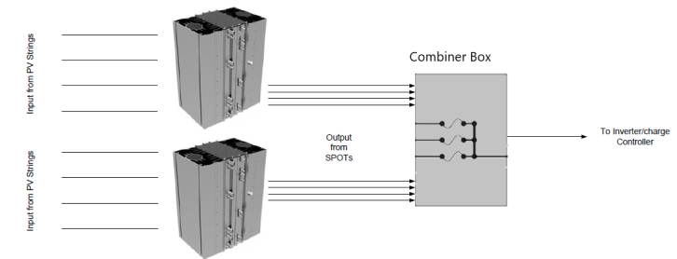
Figure 4: SPOT units placed between PV panel and combiner.

There is a continually growing number of applications in which the SPOT device can be used, some of the most common include:
- In the construction of a new PV system when a centralized inverter has limited number of MPPT inputs.
- In the construction of a new PV system when a centralized inverter shares the DC bus with a battery storage system.
- In repowering of PV systems when old, centralized inverter is replaced with several transformer-less inverters.
- In repowering of PV systems when PV strings have degraded and cannot deliver required DC voltage.
- In repowering of PV systems augmented with a battery storage system.
In these applications, SPOTs are installed between PV strings and the combiner boxes that feed a 3rd party inverter.

4.1 New PV Plants
The SPOT allows for a more granular level of MPPT compared to a central inverter, as such it is measurably beneficial to a newly constructed PV plant. Additionally, new plants including SPOTs into initial system design, can reduce balance of system (BoS) cost.
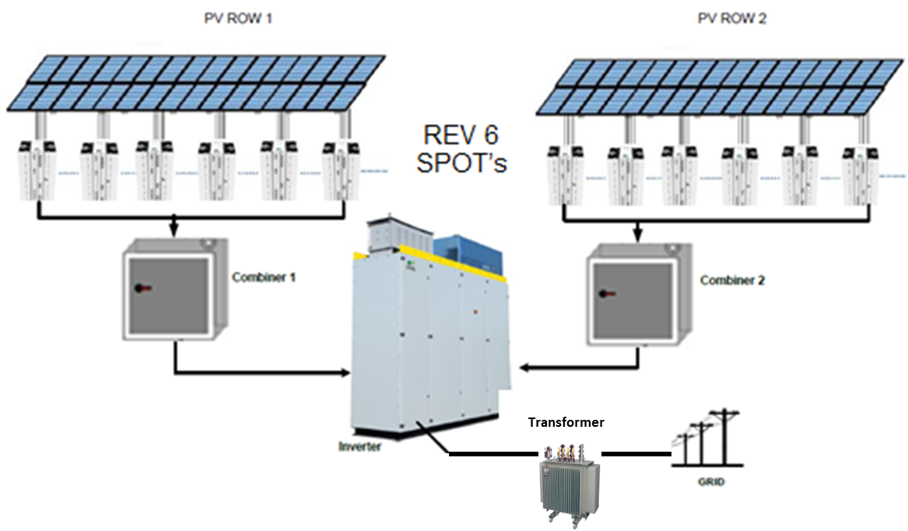
Figure 5: Diagram of deployed SPOT units in a newly constructed PV plant

4.2 Solar + Storage
The SPOT is a unique solution for DC-coupling of PV and Storage. When deployed with storage systems i.e., batteries, the DC bus may be shared with the storage terminal as shown in Figure 6. In this case, the inverter typically operates in a constant voltage mode. The SPOT(s) will match PV voltage to the battery voltage and provide granular MPPT.
Figure 6: Diagram of a DC-coupled Solar + Storage system using the SPOT

4.3 Repowering of Older PV Plants
Large scale PV projects installed in past decades typically used 600V rated PV modules and 600V inverters which are in turn connected to a medium voltage distribution transformer as shown in Figure 7. Typically, in these older 600V installations, an insulation transformer was built into the inverter. This integrated transformer carried out two functions:
- Matched lower (208 VAC) AC voltage on the inverter output to higher 480VAC voltage on the distribution transformer’s primary winding.

- Provided galvanic isolation between PV array’s ground - PV arrays are generally negatively grounded, though in some cases are positively grounded - and the neutrally grounded distribution transformer.
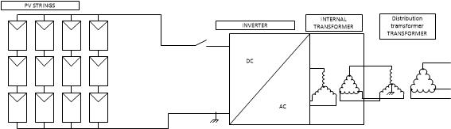
Figure 7: Negatively grounded PV array connected to neutrally grounded Inverter

Older 600V inverters have been largely replaced by more efficient, 1000V, transformer-less string inverters that are connected directly to the MV distribution transformer as shown in Figure 8 below. This newer type of string inverter must produce 480VAC on its output to match the primary voltage requirement of the MV distribution transformer. This requires a DC input voltage of 680 – 1000VDC.
When replacing an older style 600V inverter with an integrated transformer for a newer, 1000V transformer-less inverter, two issues must be considered:
- Matching the input voltage from the older 600V array to the higher input voltage required by the new inverter.

- Assuring the inverter’s AC output matches the ground potential of the primary winding of the MV distribution transformer.
Neither of these requirements can be met by the transformer-less string inverter alone.
Figure 8: A typical 600V PV plant with Alencon spots and a transformer-less inverter

The SPOT as shown in Figure 8 resolves both problems because the SPOT essentially serves as a DC transformer. The SPOT will map the lower PV voltage range into the higher DC input range of the new, transformer-less string inverter. At the same time, the SPOT will reintroduce the galvanic isolation lost when the transformer from the older inverter was removed. The SPOT provides galvanic isolation between PV and the ground potential of the primary winding of the MV distribution transformer assuring that any mismatches in ground potential are automatically resolved.

5 Technical Specifications
SPOT Model | SPOT 600/1000 | SPOT 1500
Input
MPPTs/Inputs per SPOT (Standard) | 4
Maximum String Voltage | 1000 V | 1500 V
String Operating Voltage | 200 – 1000 V | 300 – 1500 V
MPPT Voltage Range | 250 – 820 V | 350 - 1300 V
Maximum Current Per Input @ 25 C | 19.2 A | 14A
Maximum Current Per Input @ 50 C | 15A | 10A
Reverse Polarity Protection | Yes
Max. Input Power per Input @ 25 C | 11.5 KW | 15.4 kW
Max. Input Power per Input @ 50 C | 9 KW | 11 kW
Grounding Configuration | Positive, Negative or Ungrounded
Output
Output Operating Voltage | Fully Configurable from 200 to 1500 V
Number of Outputs | 4
Maximum Power Rating Per Output @ 25 C | 19.2 KW | 18.9 kW
Maximum Power Rating Per Output @ 50 C | 12 KW | 11.8 kW
Reverse Polarity Protection | Yes
Efficiency
Peak Efficiency | 98.5%
CEC Weighted Efficiency | 98%
Standards & Compliance
Certifications | UL1741, IEC 62109-1, CSA C22.2
Environmental
Storage Temperature | -40°C to 85°C
Cooling | Natural Convection and Forced Air
Environmental Rating | NEMA 4 & IP 66
Humidity | 0-95%
Operating Ambient Temp. | -40°C to 50°C
Form Factor
Packaging | Rail or Rack Mounted, Outdoor Rated
Size (H x W x D) | SPOT – 0.64m * 0.42m * 0.27m  w/ FEED – 0.64m *0.44m * 0.39m
Weight | 32 - 51 KG (based on configuration)

6 Isolators / Disconnects
Alencon requires using disconnects (or contactors) to enable an electrical cut-off of the SPOT from its input power source.
Always disconnect SPOT from input power when performing maintenance on the SPOT.
Disconnects must be rated to the max input voltage and UL approved
Do not disconnect the SPOT output while under load by disconnecting from the output. Always use an appropriately rated disconnect to isolate SPOT from input power before disconnecting the output.
You may select from one of four options:
- Alencon Fused Electrical Disconnect (FEED)
- Alencon Isolated Disconnect (AID)
- Third party disconnects: IMO Disconnects
- Alencon Ground Arc Rapid Disconnect (GARD)

6.1 Alencon Fused Electrical Disconnect (FEED)
Alencon’s FEEDTM (Fused Electrical Disconnect), see Figure 133, provides a configurable add-on device to SPOT input and output. Mounted directly onto the SPOT front, the FEED is used to add disconnects and over-current protection via fuses to PV strings connected to the SPOT. As well, FEED offers PV grounding with ground-fault detection.
FEED is only available for deployment indoors as it is not weather rated.
See more about FEED options in FEED Manual.
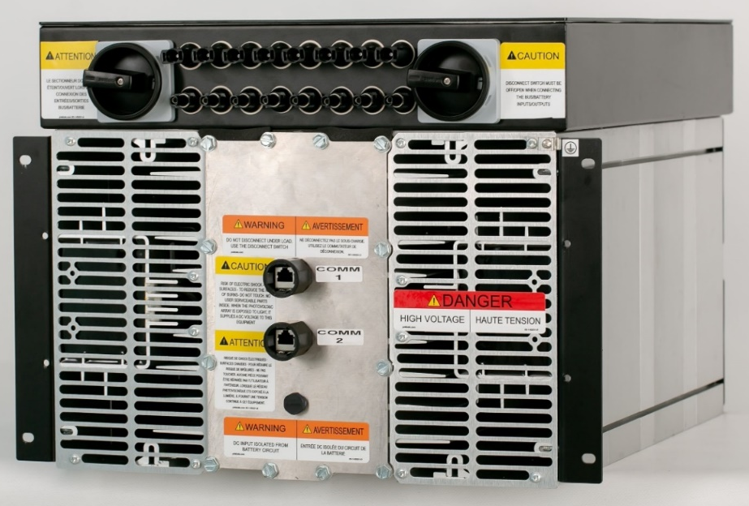
Figure 9: Alencon SPOT with Fused Electrical Disconnect

6.2 Alencon Isolated Disconnect (AID)
Alencon offers a 4-input fused disconnect box (fuses are optional). Both positive and negative terminals of PV strings are isolated from the SPOT when the Switch is in the OFF position.
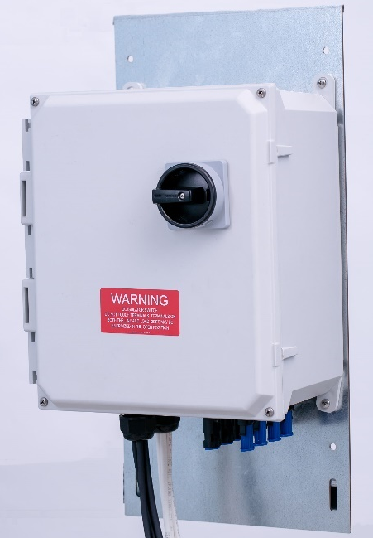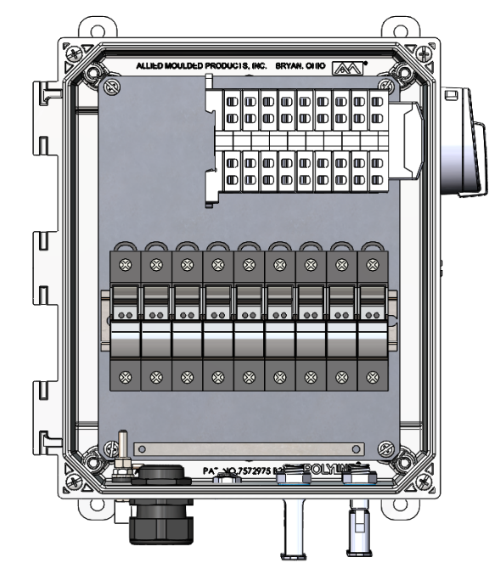
Figure 10: Alencon Isolated Disconnect (external and Internal)
The AID may be mounted on the side of SPOT or on a separate Unistrut hanging plate and wired directly into SPOT inputs.

6.3 Third Party Disconnects
Third party disconnect switches can be used such as IMO’s DC isolators, though the other options are recommended instead. A typical IMO DC-isolator is shown below in Figure 11.
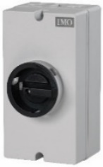
Figure 11: An IMO manual DC isolator

Any third party disconnects should be UL-listed for use with 600 V, 1000 V, and 1500 V systems. Below, Figure 12 shows an example of IMO disconnects installed in a PV array.

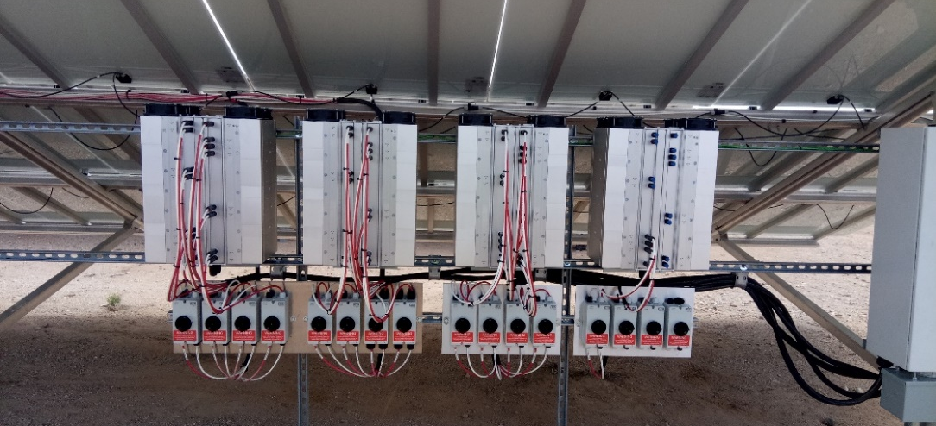
Figure 12: SPOTs with IMO disconnect

6.4 Alencon GARDTM
Alencon’s GARDTM (ARC-GROUND-RAPID DISCONNECT) see Figure 13, provides maximum protection to SPOT input. It detects arc fault, ground fault and rapid disconnects on all four input cannels of the spot.
See more about GARD in GARD User Manual.
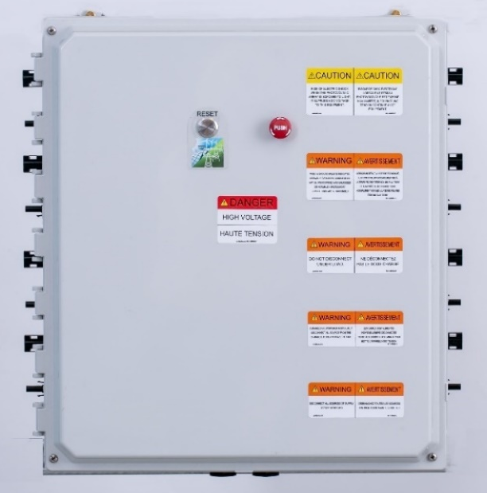
Figure 13: GARD

7 SPOT Hardware
Each SPOT is assembled into a hermetically sealed NEMA4x/IP66 enclosure as shown in the Figure 14. The enclosure is designed to be mounted vertically or horizontally depending on the deployment.
Vertical mounting – directly mounted using Unistrut on any of the posts that serve as structural support to the racking system where solar modules are installed.
Horizontal mounting – SPOT can be installed horizontally in a rack system. Typically, this is used for indoor deployments, when the FEED add-on product is included (see section 6.1).
The heat generated within the enclosure is extracted via an external passive heat exchanger.
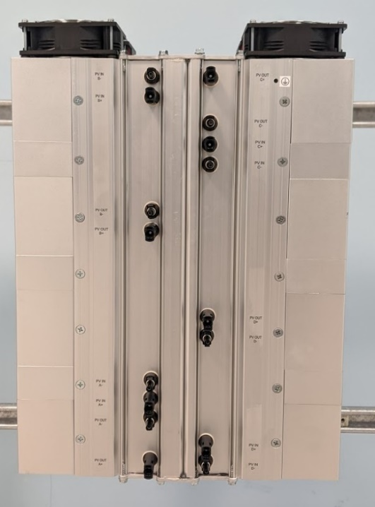
4 Inputs / 4 Output SPOT
Figure 14: Solar Power Optimizer and Transmitter (SPOT) – Vertical Mount
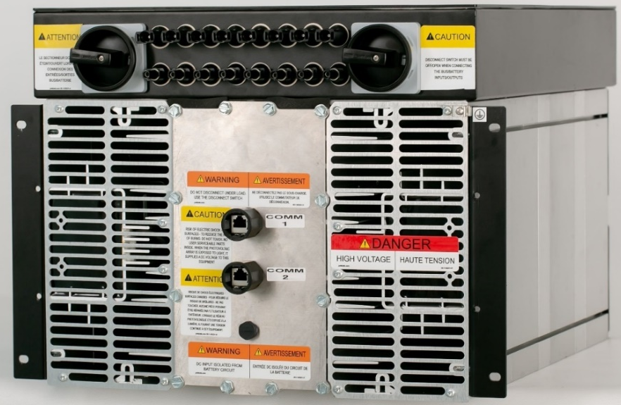
4 Inputs / 4 Output SPOT
Figure 15: SPOT with Fused Electrical Disconnect (FEED) – Horizontal Mount

7.1 SPOT Dimensions – Vertical Mount
The images below provide the dimensions to which the SPOT (vertical mount) has been designed and built. SPOT of this configuration weighs 51.25 kg or 113 lbs.
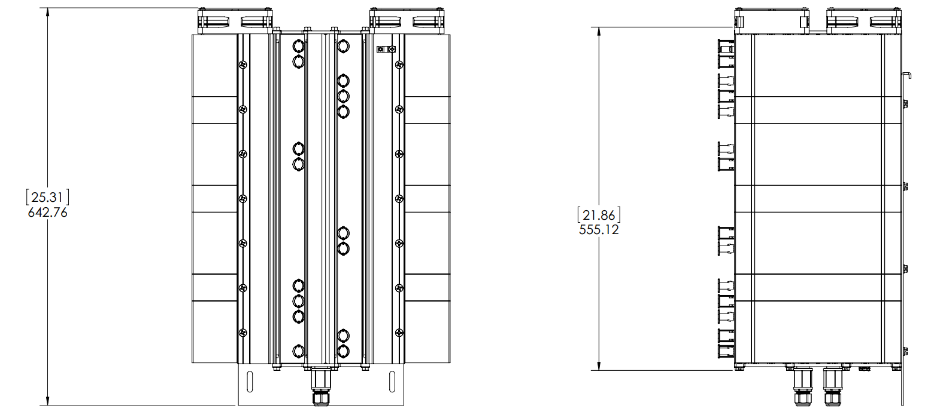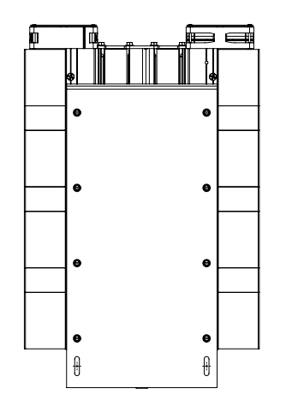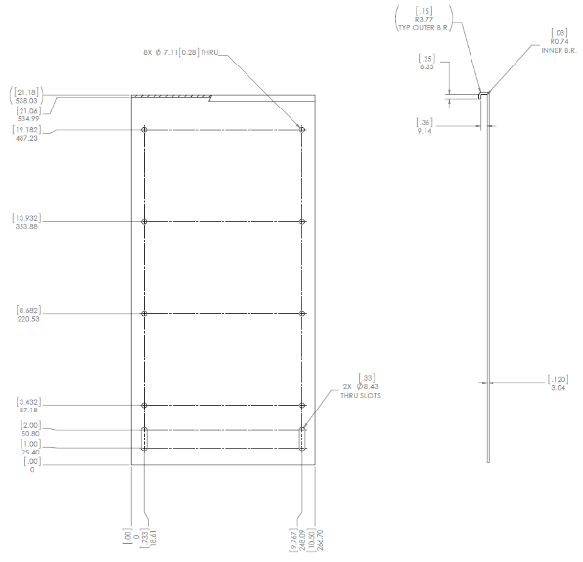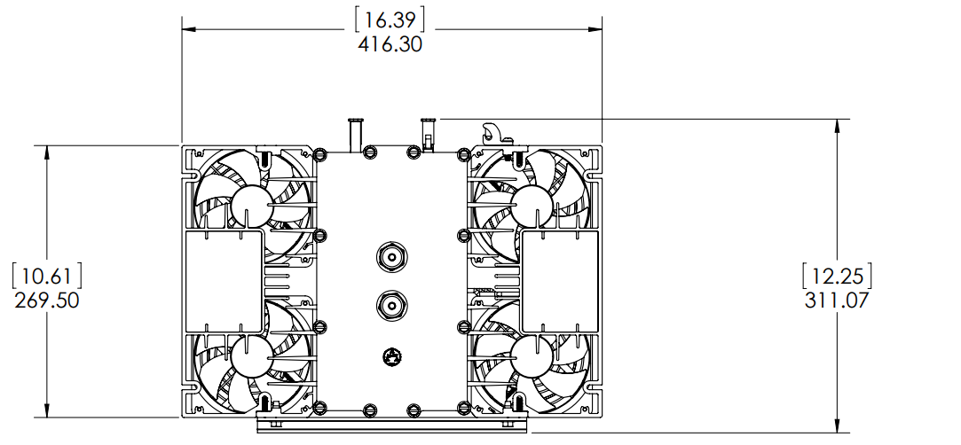
Figure 16: SPOT Dimensions including back plane for hanging

7.1 SPOT with FEED Dimensions – Horizontal Mount
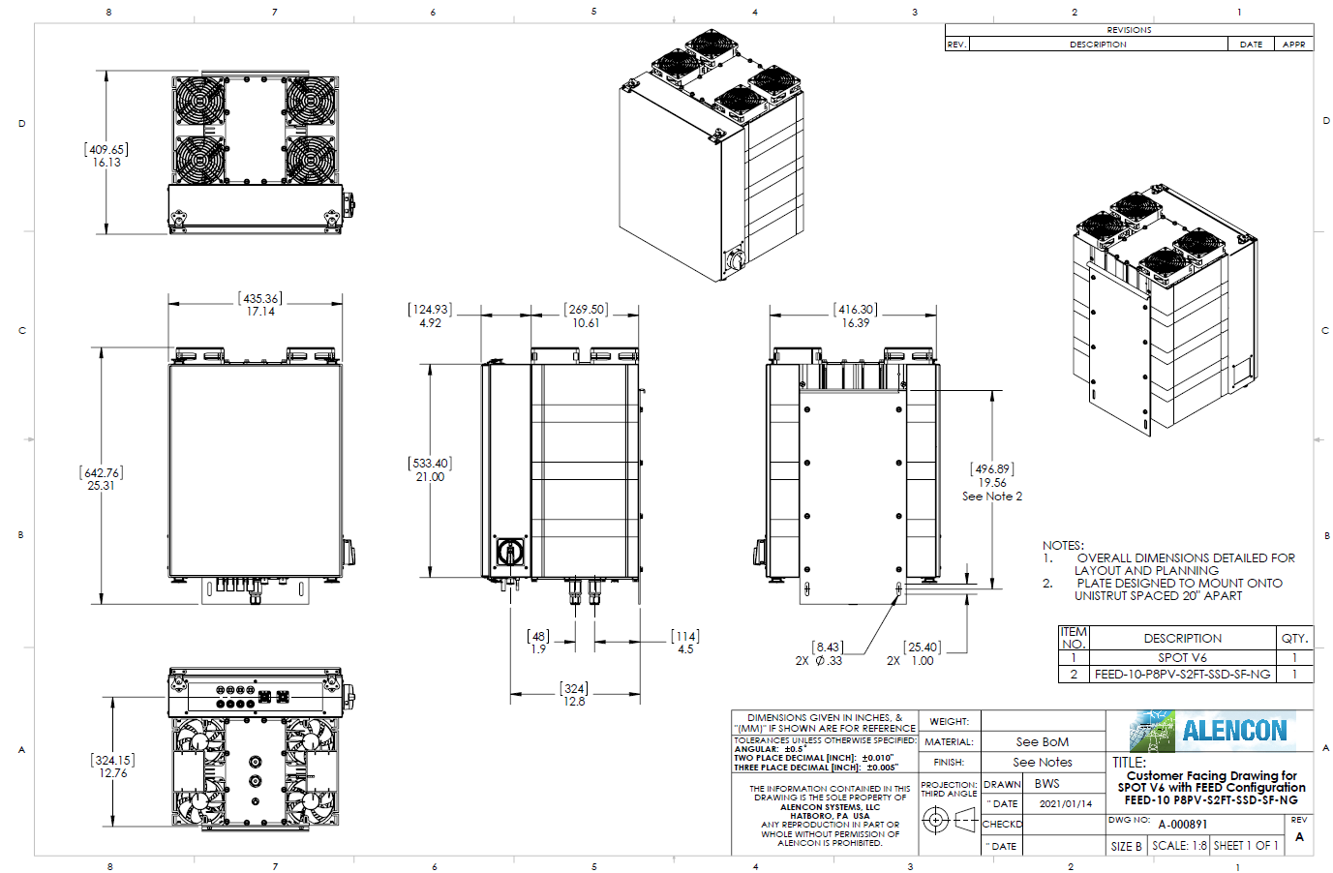
The images below provide the dimensions to which the SPOT with FEED (horizontal mount) has been designed and built. SPOT of this configuration weighs 69.4 kg or 153 lbs.
Figure 17: SPOT with FEED Dimensions

8 Installation
Only skilled professionals with experience installing electrical systems should perform installation of the SPOT. Persons installing the SPOT should be able to lift 50 lbs. without assistance. At least 2 persons are required to install the SPOT.
Installation instructions should be followed exactly; improper installation of the SPOT could void the warranty of the SPOT and any or all its component parts. Thoroughly read any project specific setup or commissioning instructions from Alencon Systems before beginning the installation.
If any instructions are unclear, or any additional information is required during the process, please contact Alencon Systems LLC for assistance (see Appendix C).

8.1 Installation Criteria – PV
The following information should be considered when selecting the topology and the locations for installation within the PV array.
PV strings exposed to sunlight represent a shock hazard at the wires and exposed terminals. Disconnect PV strings while performing the installation to reduce the risk of shock during the process. Test any wire or terminal for presence of high voltage before touching them.

8.1.1 Voltage and Current Requirements
The string voltage at the power optimizer must never exceed its rated input voltage, (i.e., 1000V for the SPOT 1000). Exposure to voltage higher than that may cause damage to the SPOT and will void the warranty.
The SPOT will not deliver any power if the input voltage is below minimum specified input voltage.
The short circuit current rating of the PV string must not exceed the rating of each input. Two PV strings may be connected to a single SPOT input if the sum of currents from both PV strings does not exceed the rating of each input.
The minimum voltage, maximum voltage and maximum current input ratings can be found on the SPOT serial number label (see section 8.3).

8.1.2 MPPT operational range
The MPPT software maximizes the efficiency of PV strings if the operating voltage is within the MPPT operational window. The SPOT will continue to operate also when the PV voltage is out of the specified MPPT range, but it must be within the overall specified voltage range. In that mode the SPOT but the system will run at lower efficiency and the harvested energy may be lower than expected.
The maximum power point voltage (V_{MPP}) of a string connected to the SPOT should be around the nominal input voltage of the SPOT.

8.2 Installation Procedure
The SPOT has been designed to be quickly deployed in the field. Much of the configuration of the system is done at the factory prior to shipping to decrease the amount of time needed for install and commissioning the system in the field.
A summary of the steps to install and prepare SPOT units for commissioning is provided below:
- Locate the system layout schematic provided by your system integrator. This diagram should show the location where each SPOT needs to go, including its LIN (Local Identification Number)
- Mount the SPOTs (Vertical or Horizontal)
- Mount Input Disconnects (if separate from the SPOT).
- Connect input power wires to disconnects (if separate from the SPOT). Disconnects should remain in OPEN position.
- Connect disconnect output wires to the SPOT inputs (if separate from the SPOT).
- Connect the output wires to the combiner box, trunk cable harness or other load. (Disconnects should remain in OPEN position or combiner boxes remain ‘off’).

8.3 Locate the System Layout Schematic and/or Installation Drawing
EPC should supply installation drawings showing the location of where each SPOT is to be installed. As well, the single line diagram should show electrical interconnections. A simplified version of such a SLD is provided below.
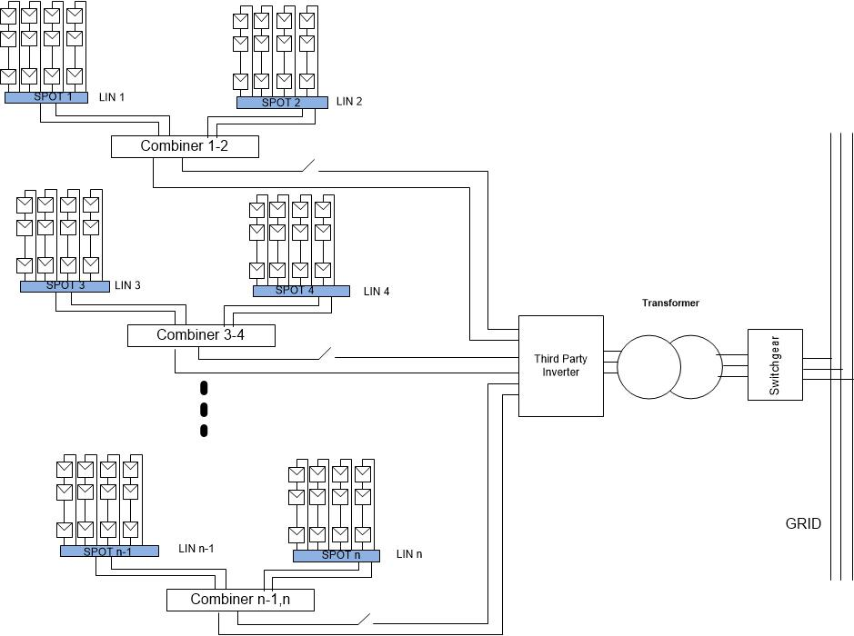
Figure 18: Sample of a Single Line Diagram (SLD)

The installation drawing indicates the location of each SPOT and shows its Local Identification Numbers (LIN). Prior to shipment, each SPOT is identified with a unique serial number. Should a SPOT need to be replaced in the field, the replacement SPOT will have same LIN as the previous SPOT but a different serial number.
A permanent label showing both the LIN and serial number of each SPOT are affixed to the bottom end cap as shown below.
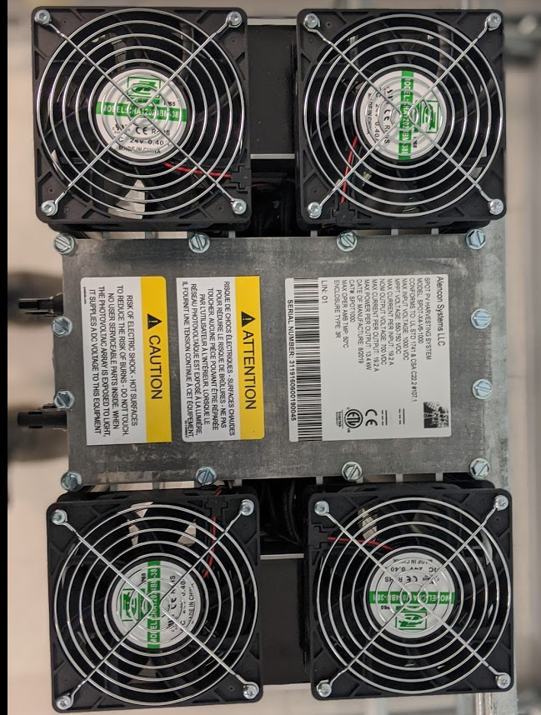
Figure 19: SPOT Bottom End Plate with commensurate labels

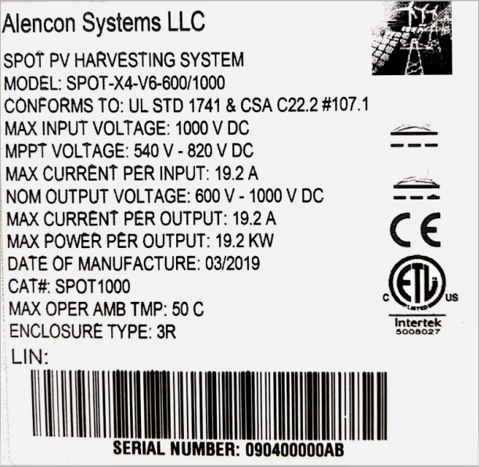
Figure 20: Sample SPOT Label

8.4 SPOT Mounting
The SPOT uses natural convection cooling. In extreme weather conditions, the metal surface of the unit can reach temperatures over 75°C (170°F); high temperatures can cause burns if in contact with the skin. When installing, ensure that the SPOT is not located in high traffic areas.

It is possible that the device has sharp edges which can cause skin cuts or lacerations if handled incorrectly. As such, it is recommended that SPOT installers take appropriate precaution such as wearing work gloves to prevent injury when hanging the SPOT.

8.4.1 Selecting Location – Vertical Rail Mount
The following considerations should be made when selecting the mounting location for the SPOT power optimizer:
Indoor/Outdoor: The SPOT uses a Nema 4X enclosure that can be mounted indoors or outdoors. For outdoor installation, it is recommended to install the device in a shaded area where it is not exposed to direct sunlight, such as underneath PV panels. In bright sun conditions, shading the SPOT will help to increase the unit’s performance under maximum power conditions and high ambient temperatures.
To ensure maximum reliability, the unit should be located away from any humidity sources such as rain, sprinklers, or sprays.
Mounting Position: The SPOT can be mounted vertically on a wall or pole. SPOT is equipped for easy mounting on horizontal Unistrut. The SPOT should be mounted to a load bearing object capable of supporting its weight (51.25 kg or 113 lbs.)
Temperature: The SPOT should be mounted at location, where ambient temperature ranges from -30 to +50 °C. The SPOT will limit power output at ambient temperatures above 50 °C

Clearance: For optimal and safe operation, make sure that the SPOT has enough clearance around the unit. If the recommended minimum clearances in table below are not met, rated performance may not be achieved.
Direction | Recommended Clearance
Above | 12 inches
Below | 24 inches
In front | 12 inches, more recommended to allow the access to the unit
On sides | 12 inches, more recommended in hot climates to prevent thermal de-rating

8.4.2 Selecting Location – Horizontal Rack Mount
The following considerations should be made when selecting the mounting location for the SPOT power optimizer with FEED add-on:
Indoor/Outdoor: The SPOT with FEED must be mounted indoors as the FEED enclosure is not outdoor rated.
Mounting Position: The SPOT can be mounted horizontally into a rack, 19” rack-mount configuration: 9U x 22.5” Deep, 25” Overall Depth. The rack must be capable of supporting its weight (69.4 kg or 153 lbs.)
Temperature: The SPOT should be mounted in a location, where ambient temperature ranges from -30 to +50 °C. The SPOT will limit power output at ambient temperatures above 50 °C
Clearance: The SPOT should have at least 30 cm (12 inches) in front for airflow and access to the cable connectors. The SPOT should have at least 15cm (6 inches) at the back to allow for proper exhaust from the cooling fans.

8.4.3 Mounting Procedure – Vertical Rail Mount
The SPOT can be easily mounted using standard Unistrut© along with spring loaded channel nuts. The SPOT V6 comes with a hooked backplate that allows for the SPOT to be hung on the Unistrut and then fastened using a Hex head screw. Recommended hardware for mounting is as follows:
- Unistrut© – Any typical zinc plated or galvanized steel Unistrut
- Strut Channel Nuts with Spring, 13/16" Channel High, 5/16-18 Thread – x2 per SPOT
- Hex Head Screw, Grade 8 Steel, 5/16"-18 Thread Size, 1" Long – x2 per SPOT
Based on OSHA and safety best practices documented in the U.S., as well as others stated in Canada, Europe and Asia, the SPOT should be lifted into position by two people as it weighs approximately 51.25 kg (113 lbs.).

To properly hang the SPOT onto a Unistrut:
- Ensure you have a strong base to mount the SPOT as seen in the image below.
- The SPOT should be lifted into position by two people as it weighs approximately 51 - 69 kg. Ensure that the SPOT is resting on the floor securely. The side with the mounting plate/bracket should be facing the floor.
- Ensure H4 connectors, cooling fans and RJ-45 connector ports are free from stress. Do not hold by any of these points when lifting.
- Strategically place your hands and once ready lift the SPOT
- Lift the SPOT until the hooked mounting plate (highlighted in orange) lines up with the Unistrut.
- Once everything is lined up you are ready to hook the SPOT in place as seen below
- Once SPOT is secured in place you must fasten the other end of the mounting bracket it to the Unistrut using 5/16th Hex Head Screws

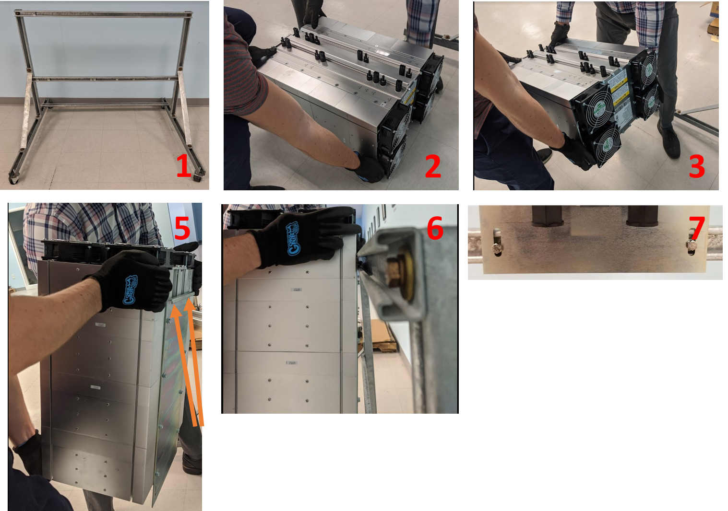
Figure 21: SPOT Mounting Instructions

8.4.4 Mounting Procedure – Horizontal Rack Mount
To properly install the SPOT into a Rack:
- SPOT with FEED shown in Figure 22 can be unpackaged and lifted onto a table or work bench to attach mounting brackets (Error! Reference source not found.)
- Using (4) of the provided ¼”-20 x 3/4 Self Tapping-Type F Screws [P-005533], securely attach the left and right mounting brackets to the SPOT unit’s side, so that ‘wings’ are flush to the front face
- SPOT can be lifted and placed into the rack
- SPOT may have a designated place within the cabinet, denoted by a numbered label on the front face which should be matched to the assigned location.
- Use 4 screws to secure each SPOT unit to the rack through the mounting brackets.
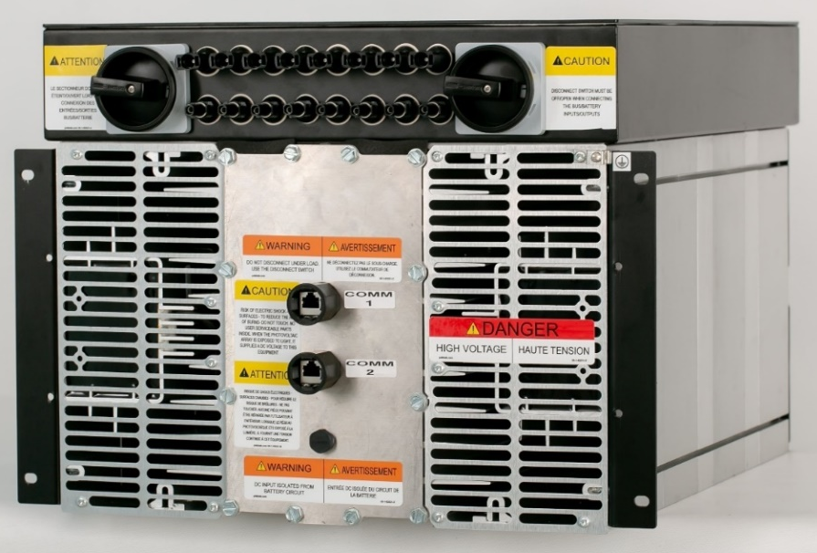
Figure 22: SPOT/BOSS with FEED and Mounting Brackets

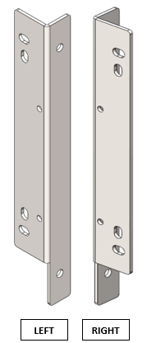
Figure 23: SPOT/BOSS with FEED and Mounting Brackets

8.5 SPOT Grounding Requirements

PV Grounding
SPOT supports positive, negative, and floating grounding schemes. The frame of the PV string should be connected to the SPOT’s grounding lug.

The size of the conductor is usually based on the size of the largest conductor in the DC system. The inputs are functionally (high impedance) coupled to the ground through the insulation monitoring circuit. Therefore, treat all terminals as a high voltage signals.

Inverter Grounding
The SPOT’s outputs are isolated from the PV array. The output (either monopolar or bipolar) is also isolated from the ground system. The SPOT supports any inverter grounding option with the assumption that the ground potential is maintained between the potentials of the negative and positive output terminals.
Shock hazard
All power terminals are considered to have a high voltage potential to ground. To reduce the risk of shock during installation, always treat all terminals as high voltage and test for voltage before touching exposed wiring. The work should be performed by qualified service personnel.
The SPOT enclosure should always be connected to earth ground (regardless of the input/output grounding schemes). Not properly grounding the SPOT enclosure can be dangerous for SPOT operators.
Ground lugs are included with every SPOT shipment and can be attached where a ground label is found on the SPOT enclosure (see examples in Figure 24).
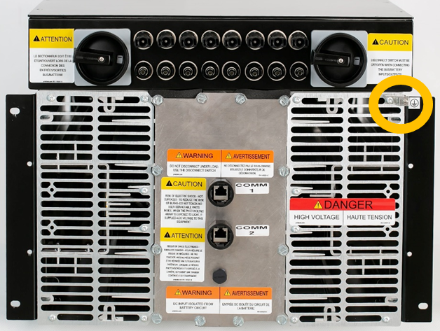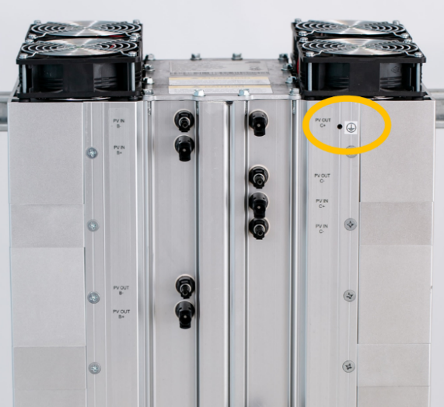
Figure 24: SPOT Ground Lug Location Examples (in Orange)

8.6 Connecting the SPOT to Input Power Source Cables
Any input power source must be able to be manually disconnected from the SPOT at will. For PV string input, an external disconnect device must be used to connect to the SPOT (see section 6).
Ensure the input is ‘off’ or disconnects are in OPEN positions, before making connections to the SPOT input ports. Keep the SPOT isolated from source until commissioning (see section 9.3).

8.6.1 SPOT Wiring Requirements
Fire Hazard: Wiring should not be undersized. The size of the wires must be selected based on the maximum short circuit current in the node. Based on the distributed SPOT topology with isolated PV inputs the wires should meet at least the rating of the individual string. Ensure wiring is in accordance with the NEC or applicable code.

8.6.2 Input Wiring
Up to four inputs are connected to a single SPOT via Amphenol H4 connectors as. The inputs and outputs of the SPOT are polarity sensitive. Keyed Amphenol H4 series solar connectors are used to ensure the proper polarity of the connection.
Inspect and assure that the plus and minus connected to each SPOT channel correspond to the same input power source.
Push together the inputs to the correct polarities as shown in the table below, and make sure they click closed.

8.6.3 SPOT Connector Terminations
SPOT inputs and outputs are terminated with Amphenol H4 connectors. The connections are made as such:
Polarity | Input Source (PV) | SPOT
Negative | Male pin | Female pin
Positive | Female pin | Male pin
Polarity | Output Load (CB) | SPOT
Negative | Male pin | Female pin
Positive | Female pin | Male pin

For more information on Amphenol H4 PV panel connectors, please see: http://www.amphenol-industrial.com/h4-pv-connector
Note: When using SPOT with FEED, different terminating connector options are available, see FEED manual for more information.

8.6.4 Short Circuit Check
After connecting SPOT to input power source, close the input disconnect and use a current clamp to check that no current flows to the SPOT through any of the 4 channels. If any current is measured, open the input disconnect immediately and contact Alencon technical support.
When finished, the input disconnect should be opened and remain open until the SPOT install has finished and SPOT is ready for commissioning to begin (see section 9.3).

8.7 Connecting the SPOT to Output/Load Cables
Ensure the output is ‘off’ or disconnects are in OPEN positions, before making connections to the SPOT output ports. Keep the SPOT isolated from load until commissioning (see section 9.3).

8.7.1 Output Wiring
Up to four outputs are connected to a single SPOT via Amphenol H4 connectors as.
Inspect and assure that the plus and minus connected to each SPOT channel correspond to the same output/load.
Push together the outputs to the correct polarities as shown in the table above, and make sure they click closed.
8.7.3 Output Fusing
Irrespective of the application, (new PV plant, Solar + Storage, PV retrofit, etc.) the SPOT requires external fusing on the output.
When using the SPOT in an application without combiner boxes, Alencon can provide an external fuse disconnect box or the FEED (see section 6.1) with appropriately rated fuses and fuse holders. SPOT outputs may be wired to a DC inverter bus through existing combiner boxes. Often, combiner boxes are equipped with fuse holders. If this is the case, install the appropriately rated fuses there.

9 Turning ON and OFF the SPOT
The SPOT is a highly autonomous device and should not require manual intervention to operate after commissioning in most applications. Basic ON/OFF can be controlled using just the input power disconnects.
In some cases, such as for maintenance or troubleshooting, the SPOT needs to be turned off and isolated from input and output. Use the full procedures below for safely turning ON and OFF the SPOT.

9.1 Steps to turn ON the SPOT:
Input and output disconnect switches should be in the OPEN position at the beginning of this process.
In most SPOT applications, the output bus (load) will start at a low voltage, such as inverters that are off. If the bus is at a voltage <300V, follow the instructions below in 9.1.1.
In cases where the output bus is already at high voltage, such as batteries, a different set of steps should be taken to avoid inrush currents, when turning the SPOT ON. If the bus is already at a voltage >300V, follow the instructions in 9.1.2.

9.1.1 Turning ON the SPOT – Low Voltage Bus (<300V)
- CLOSE any output disconnects and/or turn ON the combiner box.
- CLOSE the input disconnects and allow power to the SPOT.
- Use a controller (PODD or otherwise), to send a System Reset command to begin the startup process on the SPOT (see section 10.1.2).
- After at least 5 minutes, measure the input and output currents using a DC clamp to verify SPOT is converting power.
- If using the PODD or another controller, telemetry can be monitored for the expected values of a SPOT operating properly.

9.1.2 Turning ON the SPOT – High Voltage Bus (>300V)
- CLOSE the input disconnects and allow power to the SPOT
- Use a controller (PODD or otherwise), to send a System Reset command to begin the startup process on the SPOT (see section 10.1.2).
- SPOT will charge its own output to high voltage, to be within 300V of the bus voltage. Use the controller or a multimeter to verify the SPOT output has stabilized at a high voltage charge.
- CLOSE any output disconnects and/or turn ON the combiner box.
- After at least 5 minutes, measure the input and output currents using a DC clamp to verify SPOT is converting power.
- If using the PODD or another controller, telemetry can be monitored for the expected values of a SPOT operating properly.

9.2 Steps to turn OFF the SPOT:
In the event of any maintenance or SPOT replacement, ensure that all SPOTs connected to the same output (disconnect switch, combiner box, etc.) are turned OFF using this process.
- If a controller is being used, a Shutdown command can be given to cease power production on SPOTs (see section 10.1.2), otherwise move to step 2.
- Input switches (or contactors, etc.) should be opened so that SPOT is isolated from any power ‘upstream’.
- Only after the input disconnects are OPEN, can the user turn off the combiner box (or other output disconnects), so the SPOT is isolated from both input and output.
- Measure the input and output DC currents using a clamp and verify no current flows to or from the SPOT. If current is still present, contact Alencon technical support directly.
- Only after step 4 can cables be disconnected from SPOT input and output ports.

9.3 Commissioning your SPOT Device
The first time installing and turning ON the SPOT device, may be a different process than turning OFF and ON as desired for maintenance, troubleshooting or other reasons after the system is fully deployed.
Commissioning the SPOT includes:
- Mounting the SPOT (section 8.4) and accessory devices.
- Connecting properly to input and output (section 8.6 – 8.7)
- Turning ON the SPOT (section 9.1)
- Establishing communications with a PODD device (see section 12)
- Implementing final configuration changes (contact Alencon technical support if necessary).
- Controlling the system to begin operating (section 10). Subsequent operation is likely autonomous.
Alencon offers live commissioning support for all system deployments using the SPOT device. Please discuss this with your Alencon Systems representative if interested.

10 SPOT Operation
Typically, the SPOT converter harvests maximum electrical energy from PV strings connected to its input. In this case the SPOT operates autonomously in MPPT mode, and no intervention is required. In cases where MPPT mode is not the default, active control will be required to some extent. This section explains the operation of a SPOT device. Distinguishing between typical and atypical SPOT operation is a key function in troubleshooting your system.

10.1 STATE Machine
Each DCDC operates as a state machine, where state transitions are autonomous with the option of intervention using control commands sent over Modbus:
Main states may have lower-level state machines incorporated within. Arrows and diamonds indicate the conditions of transfer from command to state or state to state. Commands can be issued from the Alencon PODD UI or the system controller via Modbus at any time.
Find explanations of the statuses, commands, and conditions below. To avoid confusion in the following sections, statuses will be CAPITALIZED, commands will be bolded, and conditions will be italicized.
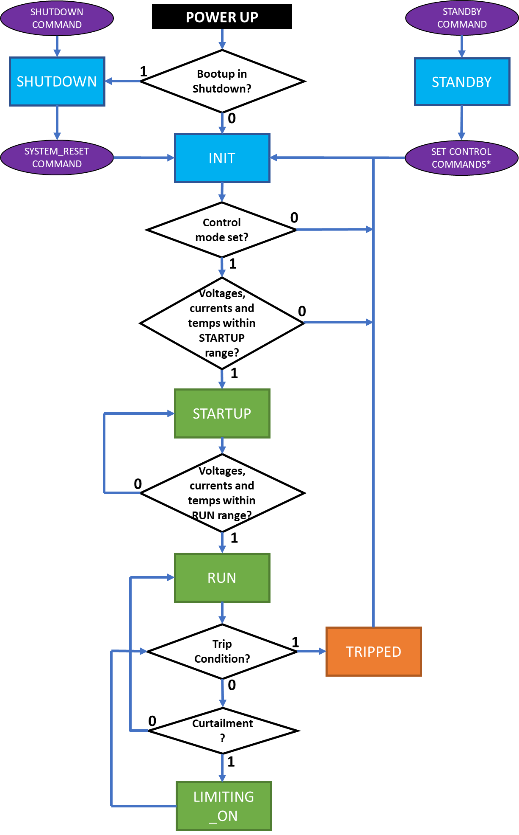

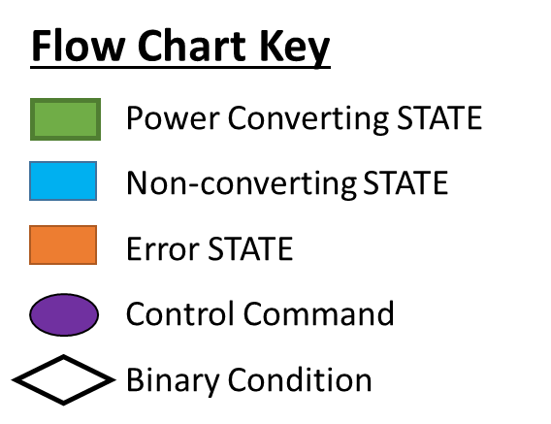

Figure 25: State Space Flow Chart
10.1.1 STATES:

SHUTDOWN
From any state the DCDC can be transferred into SHUTDOWN state upon receiving a Shutdown command. In the SHUTDOWN state the operation of the DCDC is ceased and transfer of power is stopped. The enable flag is set to 0. The DCDC stays in the SHUTDOWN state until a System Reset command sets the enable flag = 1.

STANDBY
The DCDC converter is not producing power. It is ready to produce power but not all startup limits are satisfied, or control mode has not been set. Does not require System Reset to exit.

INIT
The microcontroller is initialized. It checks whether, enable flag = 0 (state to SHUTDOWN) or enable flag = 1 (state to RUN)

STARTUP
In the STARTUP state, the DCDC prepares the load for the RUN state. First the DCDCs charge the connected output BUS (inverter and other connected electronics) to the operating voltage defined in the configuration file. When run limits are satisfied, the DCDC transitions to the RUN state unless a fault occurs mid-transition.

RUN
Operates at full power constantly adjusting for MPPT. Or operates in current/power control mode, maintaining a consistent setpoint as requested from the controller.

LIMITING_ON
If curtailment is enabled and the DCDC is operating within the predefined curtailment limits, the DCDC will go to LIMITING_ON status. DCDC continues to operate at reduced power throughput, according to the application specific droop curve that has been pre-configured. If operating conditions return to standard run limits, the DCDC will return to RUN status.
For more information see the Alencon Whitepaper on DCDC curtailment.

TRIPPED
If, while in RUN or LIMITING_ON status, voltage, current or temperature exceed the pre-configured limits on any DCDC (i.e., hit a trip condition) it will enter TRIPPED state and move automatically to INIT state. When TRIPPED state is entered, the DCDC stops all power conversion. Entering TRIPPED does not remove the control mode or set the enable flag = 0.

10.1.2 COMMANDS
The following list contains the most common and useful commands that can be given to the SPOT from the PODD UI or external controller via Modbus. For full details on available Modbus commands and registers, please request Modbus Maps from your Alencon representative or Technical Support.
- Clear Error – remove error code flags from the UI, by setting error code to 0. This has no effect on the state machine/operational flow of the SPOT.
- Shutdown – set the DCDC converter to the SHUTDOWN state and cease all power production.
- System Reset – initialize the DCDC converter to accept operating commands, which can be actively or automatically delivered.
- Standby – set the DCDC converter to the STANDBY state and cease all power production
- Set Control – Issue operating commands for how the SPOT should produce power. Including control mode, setpoint, and setpoint timeout.
  - Options for control mode include:
    - MPPT – default autonomous operation (doesn’t require setpoint)
    - Constant power – requires actively choosing the power setpoint
    - Constant current – requires actively choosing the current setpoint

10.1.3 CONDITIONS

Bootup in shutdown
This condition when set to 1 requires a System Reset command each time the SPOT is turned on (i.e., gets input power). As default this is set to 0, so the SPOT operates with the sun cycle.

Control mode set
This is set to MPPT as default for most SPOT units. In some cases, different control modes will be used on the SPOT including:
- Primary current
- Secondary current
- Primary power
- Secondary power
For control mode set to evaluate as true; the control mode, the setpoint, and the setpoint timeout must be written (except when control mode = MPPT).

Voltages, currents, temps within STARTUP range (Startup limits)
Tests operating conditions are in the permissible startup range as defined in the config file, including:
- On board temperature
- Transistor temperature
- Input and Output Voltages

Voltages, currents, temps within RUN range (Run limits)
Tests operating conditions are in the permissible run range as defined in the config file, including:
- On board temperature
- Transistor temperature
- Input and Output Voltages
- Input and Output Currents

Trip condition
Tests operating conditions don’t exceed the operating boundaries as defined in the config file, including:
- On board temperature
- Transistor temperature
- Input and Output Voltages
- Input and Output Currents

Curtailment (Curtailment enabled & curtailment limits)
Tests operating conditions have entered the curtailment zone as defined in the config file. Corresponding curtailment options must be enabled within the config file as well, there are many curtailment options available. For more information see the Alencon Whitepaper on DCDC curtailment.

11 Maintenance and Servicing

11.1 General Maintenance
If the SPOT is not operating as expected, attempt the following basic troubleshooting methods to regain proper operation:
- Check input power source for proper function. If source is PV, look for dirty or shaded modules on the string.
- Check any output fuses for continuity. If any fuses are blown, SPOT should be turned OFF (section 9.2), fuse replaced and then SPOT can be turned back ON (section 9.1)
- Use the controller to send a Shutdown command, followed by a System Reset command, give the SPOT a few minutes to restart power conversion.
- Us the disconnect switch to turn OFF and ON the SPOT, give it a few minutes to restart power conversion.
If SPOT still does not operate as expected, please contact Alencon Systems technical support for assistance with troubleshooting (see Appendix C).

11.2 Service and Repair
Due to the UL rating of the SPOT, it is not a field serviceable device, in most instances. If your SPOT is determined to be damaged, it will need to be returned to Alencon systems.
If the SPOT requires servicing, disconnect it following the turn OFF procedure (section 9.2) and request an RMA (return merchandise authorization) from Alencon Systems technical support. Then following the RMA process, the damaged SPOT will be returned to Alencon Systems or an authorized Alencon service agent.

12 Alencon Communication Environment (ACE)
For more information refer to the PODD User Manual

12.1 System Overview
Alencon’s Communications Environment, the ACE, is an Internet of Things (IoT) hardware and software solution for controlling and monitoring your alternative energy assets utilizing Alencon’s PODD device. The PODD can be used with other Alencon products including the SPOT, GARD and BOSS. The PODD acts as a gateway to integrate Alencon’s power electronics with your plant level control systems or as a standalone controller and troubleshooting device.
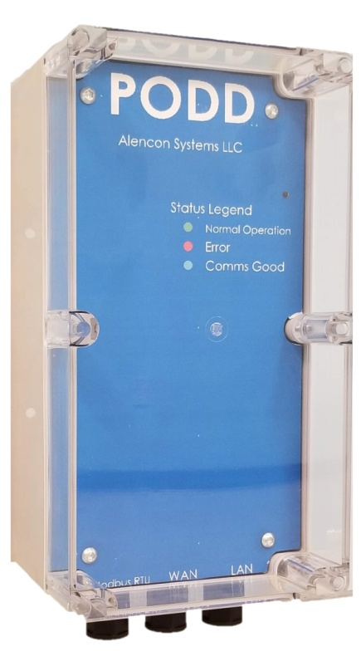
Figure 26: PODD - Points of Data Distribution device

Appendix A - Safety Precautions

A.1 Degree of Danger Symbols
 | Warning! | Warnings indicate conditions, which if not observed, can cause personal injury!
 | Caution! | Cautions are included to help you avoid damaging hardware or losing data.
 | Note! | Notes provide optional additional information.

A.2 Electrical hazards

A.2.1 Electric shock from live voltage
High voltages are present at the equipment and its components. Some maintenance work must be done when voltage is present. Failure to adhere to the safety messages may lead to severe or lethal injuries due to electric shock. To avoid electric shock from live voltage:
- Wear class 2 personal protective equipment.
- Always perform work in compliance with the regulations specified in 29 CFR, Chapter XVII, Part 1910 (OSHA), NEC, and NFPA 70E.
- Do not touch any live components of the equipment or the medium-voltage grid.
- Follow all instructions precisely.
- Observe safety messages.
- Before performing any work on the equipment, always disconnect the equipment if voltage is not
- absolutely necessary.
- After disconnecting the equipment, wait at least 10 minutes for the equipment's capacitors to discharge completely.
- Before performing work on the equipment, ensure that no voltage is present (with a Voltmeter or other measuring instrument).

A.2.2 Electric shock caused by ground fault
If a ground fault occurs, plant sections that are supposedly grounded may in fact be live. Failure to adhere to the safety messages may lead to severe or lethal injuries due to electric shock. To avoid electric shock from ground faults:
- Ensure that no voltage is present before touching any components.
- Wear class 2 personal protective equipment.

A.2.3 Electric shock due to damaged equipment
Operating damaged equipment can lead to hazardous situations that may result in serious or lethal injuries caused by electric shock. To avoid electric shock from damaged equipment:
- Only operate the equipment if it is in safe and technically faultless working order.
- Only operate the equipment if there is no visible damage.
- Regularly check the equipment for visible damage.
- Make sure that all external safety equipment is always freely accessible.
- Make sure that all safety equipment is in good working order.

A.3 Environmental hazards

A.3.1 Danger to life due to blocked escape routes
In hazardous situations, blocked escape routes can lead to serious injury or death. To avoid harm from blocked escape routes:
- An escape route of at least 3 ft. (915 mm) wide must always be available.
- Do not place any objects in the escape route area.
- Remove all tripping hazards from the escape routes.

A.3.2 Damage to the equipment caused by dust or moisture penetration
Dust intrusion or moisture penetration can damage and impair the functionality of the equipment. To avoid damage from dust or moisture penetration:
- Do not open the equipment when it is raining or when humidity exceeds 95%.
- Perform maintenance on the SPOT-BOX only when the environment is dry and free of dust
- Always cover electrical bus channel prior activating the equipment.

A.3.3 Danger to life due to electric shock when the equipment is unlocked
Unlocked equipment can be opened by unauthorized persons. This means that unauthorized persons have access to components on which lethal voltages are present. To avoid danger from unlocked equipment:
- Ensure that unauthorized persons have no access to the equipment.
- Always lock the equipment
- Keep the electrical bus channel covered

Appendix B – Glossary
Word(s)/Acronyms | Definition
ALS | ALENCON Systems, LLC
DC | Direct Current
ESD | Electrostatic Discharge
ESS | Energy Storage System
FEED | Fused Electrical Disconnect
GFDI | Ground-Fault Detection
GND | System Ground Potential
HV / LV | High Voltage / Low Voltage
IP | Internet Protocol
LD | Leak Detector
PODD | Point of Data Distribution
RTU | Remote Terminal Unit. Microprocessor controlled electronic protocol to exchange data with other devices
SCADA | Supervisory Control and Data Acquisition system. Performed by transmitting telemetry data to a master system and by using messages from the master supervisory system to control connected objects
SPOT | String Power Optimizes and Transmitters
SPOT-BOX | Container with (1) to (4) SPOT’s and Junction Box

Appendix C – Technical Support and Assistance
Visit the Alencon Systems web site at www.alenconsystems.com where you can find the latest information about the product. Contact your distributor, sales representative, or Alencon Systems’ technical support if you need additional assistance. Please have the following information ready before you call:
- Product name, serial number, and LIN (all can be located on the product label)
- Description of your peripheral attachments including fusing and cables
For technical support please email: support@alenconsystems.com or call +1 (215) 816-3366

